**MainActivity.java**

**import** android.app.Activity;

**import** android.app.AlertDialog.Builder;

**import** android.content.Context;

**import** android.database.Cursor;

**import** android.database.sqlite.SQLiteDatabase;

**import** android.os.Bundle;

**import** android.view.View;

**import** android.view.View.OnClickListener;

**import** android.widget.Button;

**import** android.widget.EditText;

**public** **class** MainActivity **extends** Activity **implements** OnClickListener

{

EditText Rollno,Name,Marks;

Button Insert,Delete,Update,View,ViewAll;

SQLiteDatabase db;

/** Called when the activity is first created. */

@Override

**public** **void** onCreate(Bundle savedInstanceState)

{

**super**.onCreate(savedInstanceState);

setContentView(R.layout.*activity_main*);

Rollno=(EditText)findViewById(R.id.*Rollno*);

Name=(EditText)findViewById(R.id.*Name*);

Marks=(EditText)findViewById(R.id.*Marks*);

Insert=(Button)findViewById(R.id.*Insert*);

Delete=(Button)findViewById(R.id.*Delete*);

Update=(Button)findViewById(R.id.*Update*);

View=(Button)findViewById(R.id.*View*);

ViewAll=(Button)findViewById(R.id.*ViewAll*);

Insert.setOnClickListener(**this**);

Delete.setOnClickListener(**this**);

Update.setOnClickListener(**this**);

View.setOnClickListener(**this**);

ViewAll.setOnClickListener(**this**);

// Creating database and table

db=openOrCreateDatabase("StudentDB", Context.*MODE_PRIVATE*, **null**);

db.execSQL("CREATE TABLE IF NOT EXISTS student(rollno VARCHAR,name VARCHAR,marks VARCHAR);");

}

**public** **void** onClick(View view)

{

// Inserting a record to the Student table

**if**(view==Insert)

{

// Checking for empty fields

**if**(Rollno.getText().toString().trim().length()==0||

Name.getText().toString().trim().length()==0||

Marks.getText().toString().trim().length()==0)

{

showMessage("Error", "Please enter all values");

**return**;

}

db.execSQL("INSERT INTO student VALUES('"+Rollno.getText()+"','"+Name.getText()+

"','"+Marks.getText()+"');");

showMessage("Success", "Record added");

clearText();

}

// Deleting a record from the Student table

**if**(view==Delete)

{

// Checking for empty roll number

**if**(Rollno.getText().toString().trim().length()==0)

{

showMessage("Error", "Please enter Rollno");

**return**;

}

Cursor c=db.rawQuery("SELECT * FROM student WHERE rollno='"+Rollno.getText()+"'", **null**);

**if**(c.moveToFirst())

{

db.execSQL("DELETE FROM student WHERE rollno='"+Rollno.getText()+"'");

showMessage("Success", "Record Deleted");

}

**else**

{

showMessage("Error", "Invalid Rollno");

}

clearText();

}

// Updating a record in the Student table

**if**(view==Update)

{

// Checking for empty roll number

**if**(Rollno.getText().toString().trim().length()==0)

{

showMessage("Error", "Please enter Rollno");

**return**;

}

Cursor c=db.rawQuery("SELECT * FROM student WHERE rollno='"+Rollno.getText()+"'", **null**);

**if**(c.moveToFirst()) {

db.execSQL("UPDATE student SET name='" + Name.getText() + "',marks='" + Marks.getText() +

"' WHERE rollno='"+Rollno.getText()+"'");

showMessage("Success", "Record Modified");

}

**else** {

showMessage("Error", "Invalid Rollno");

}

clearText();

}

// Display a record from the Student table

**if**(view==View)

{

// Checking for empty roll number

**if**(Rollno.getText().toString().trim().length()==0)

{

showMessage("Error", "Please enter Rollno");

**return**;

}

Cursor c=db.rawQuery("SELECT * FROM student WHERE rollno='"+Rollno.getText()+"'", **null**);

**if**(c.moveToFirst())

{

Name.setText(c.getString(1));

Marks.setText(c.getString(2));

}

**else**

{

showMessage("Error", "Invalid Rollno");

clearText();

}

}

// Displaying all the records

**if**(view==ViewAll)

{

Cursor c=db.rawQuery("SELECT * FROM student", **null**);

**if**(c.getCount()==0)

{

showMessage("Error", "No records found");

**return**;

}

StringBuffer buffer=**new** StringBuffer();

**while**(c.moveToNext())

{

buffer.append("Rollno: "+c.getString(0)+"\n");

buffer.append("Name: "+c.getString(1)+"\n");

buffer.append("Marks: "+c.getString(2)+"\n\n");

}

showMessage("Student Details", buffer.toString());

}

}

**public** **void** showMessage(String title,String message)

{

Builder builder=**new** Builder(**this**);

builder.setCancelable(**true**);

builder.setTitle(title);

builder.setMessage(message);

builder.show();

}

**public** **void** clearText()

{

Rollno.setText("");

Name.setText("");

Marks.setText("");

Rollno.requestFocus();

}

}

**Activity_main.xml**

<?xml version=*"1.0"* encoding=*"utf-8"*?>

<AbsoluteLayout xmlns:android=*"http://schemas.android.com/apk/res/android"*

android:layout_width=*"match_parent"*

android:layout_height=*"match_parent"*>

<TextView

android:layout_width=*"wrap_content"*

android:layout_height=*"wrap_content"*

android:layout_x=*"50dp"*

android:layout_y=*"20dp"*

android:text=*"Student Details"*

android:textSize=*"30sp"* />

<TextView

android:layout_width=*"wrap_content"*

android:layout_height=*"wrap_content"*

android:layout_x=*"20dp"*

android:layout_y=*"110dp"*

android:text=*"Enter Rollno:"*

android:textSize=*"20sp"* />

<EditText

android:id=*"@+id/Rollno"*

android:layout_width=*"150dp"*

android:layout_height=*"wrap_content"*

android:layout_x=*"175dp"*

android:layout_y=*"100dp"*

android:inputType=*"number"*

android:textSize=*"20sp"* />

<TextView

android:layout_width=*"wrap_content"*

android:layout_height=*"wrap_content"*

android:layout_x=*"20dp"*

android:layout_y=*"160dp"*

android:text=*"Enter Name:"*

android:textSize=*"20sp"* />

<EditText

android:id=*"@+id/Name"*

android:layout_width=*"150dp"*

android:layout_height=*"wrap_content"*

android:layout_x=*"175dp"*

android:layout_y=*"150dp"*

android:inputType=*"text"*

android:textSize=*"20sp"* />

<TextView

android:layout_width=*"wrap_content"*

android:layout_height=*"wrap_content"*

android:layout_x=*"20dp"*

android:layout_y=*"210dp"*

android:text=*"Enter Marks:"*

android:textSize=*"20sp"* />

<EditText

android:id=*"@+id/Marks"*

android:layout_width=*"150dp"*

android:layout_height=*"wrap_content"*

android:layout_x=*"175dp"*

android:layout_y=*"200dp"*

android:inputType=*"number"*

android:textSize=*"20sp"* />

<Button

android:id=*"@+id/Insert"*

android:layout_width=*"150dp"*

android:layout_height=*"wrap_content"*

android:layout_x=*"25dp"*

android:layout_y=*"300dp"*

android:text=*"Insert"*

android:textSize=*"30dp"* />

<Button

android:id=*"@+id/Delete"*

android:layout_width=*"150dp"*

android:layout_height=*"wrap_content"*

android:layout_x=*"200dp"*

android:layout_y=*"300dp"*

android:text=*"Delete"*

android:textSize=*"30dp"* />

<Button

android:id=*"@+id/Update"*

android:layout_width=*"150dp"*

android:layout_height=*"wrap_content"*

android:layout_x=*"25dp"*

android:layout_y=*"400dp"*

android:text=*"Update"*

android:textSize=*"30dp"* />

<Button

android:id=*"@+id/View"*

android:layout_width=*"150dp"*

android:layout_height=*"wrap_content"*

android:layout_x=*"200dp"*

android:layout_y=*"400dp"*

android:text=*"View"*

android:textSize=*"30dp"* />

<Button

android:id=*"@+id/ViewAll"*

android:layout_width=*"200dp"*

android:layout_height=*"wrap_content"*

android:layout_x=*"100dp"*

android:layout_y=*"500dp"*

android:text=*"View All"*

android:textSize=*"30dp"* />

</AbsoluteLayout>

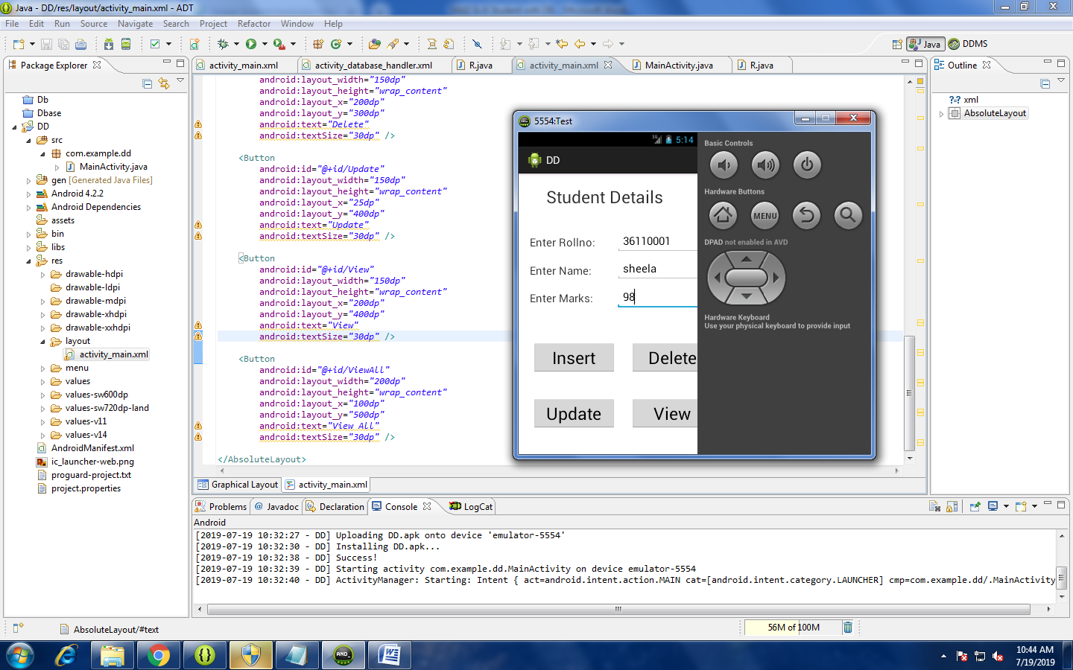

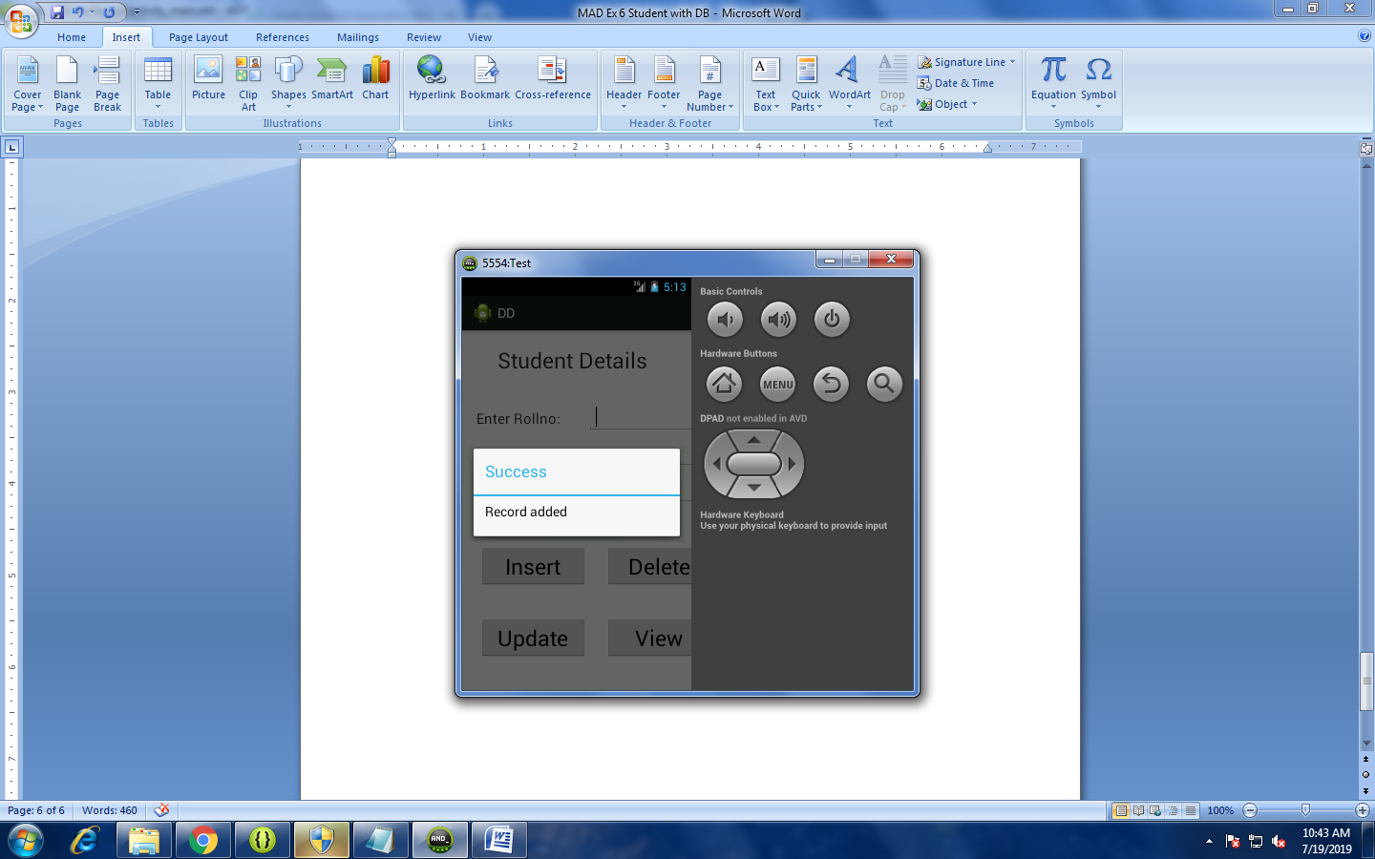

Try all the operation its working.